## Reports Menu/Daily Reports/Order Completion Performance

Request:

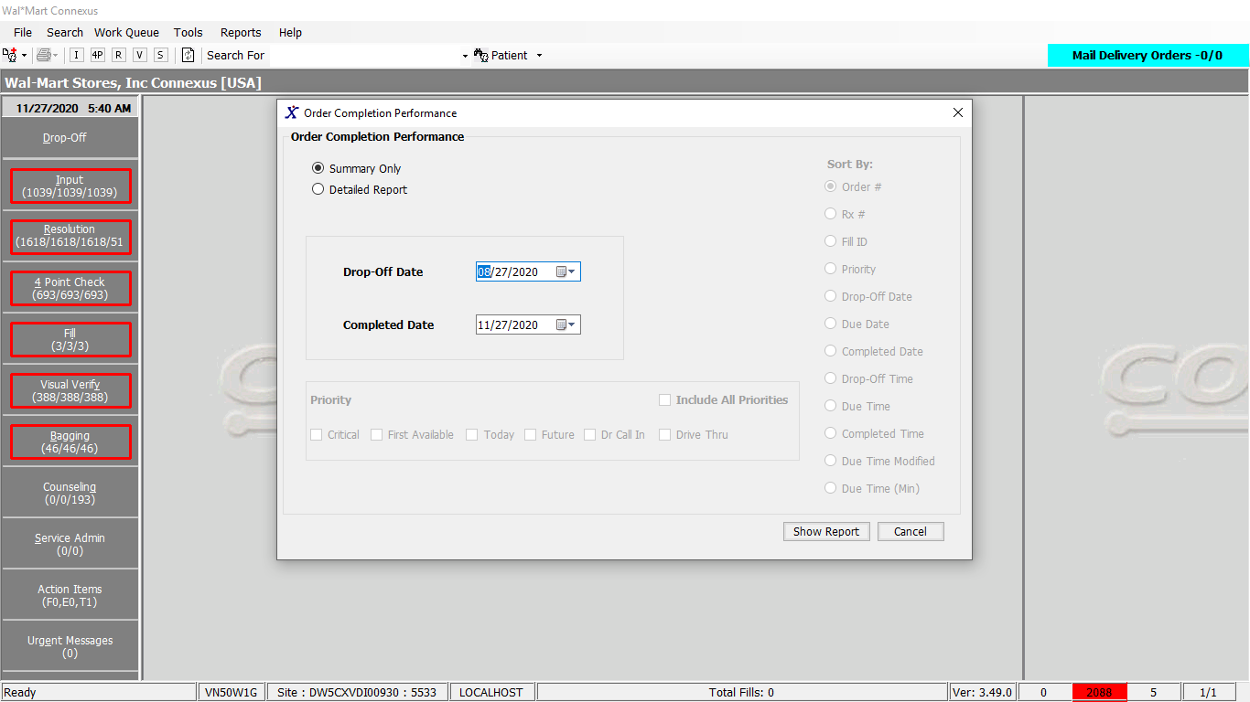

Response:

Summary report:

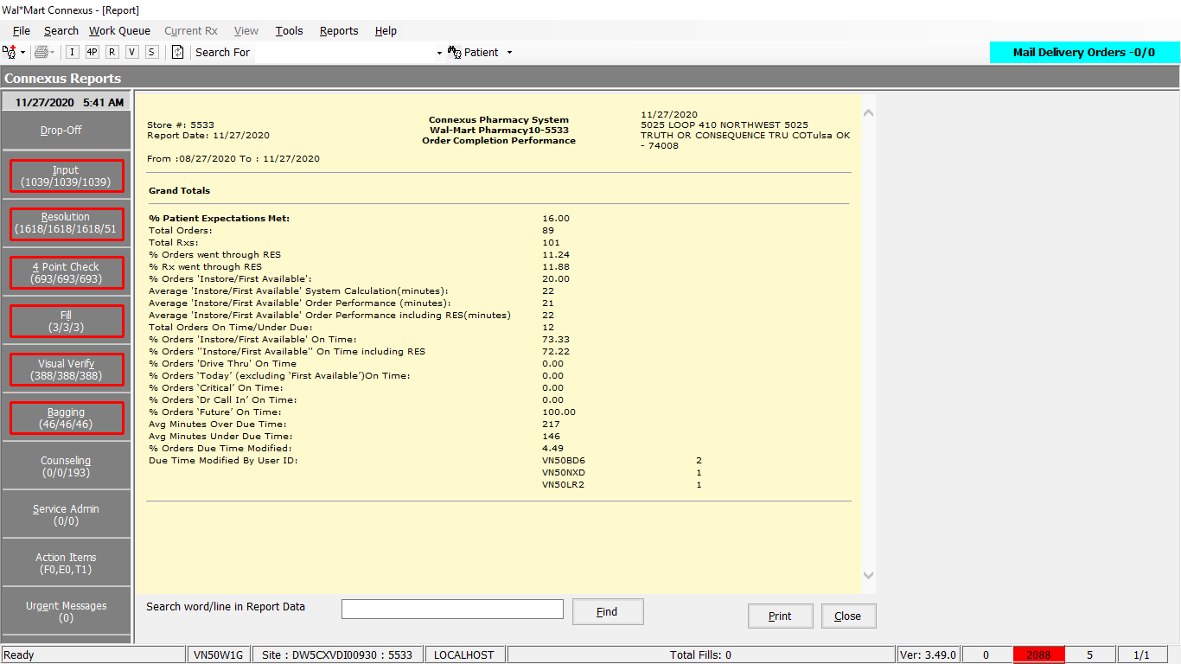

Detailed Report:

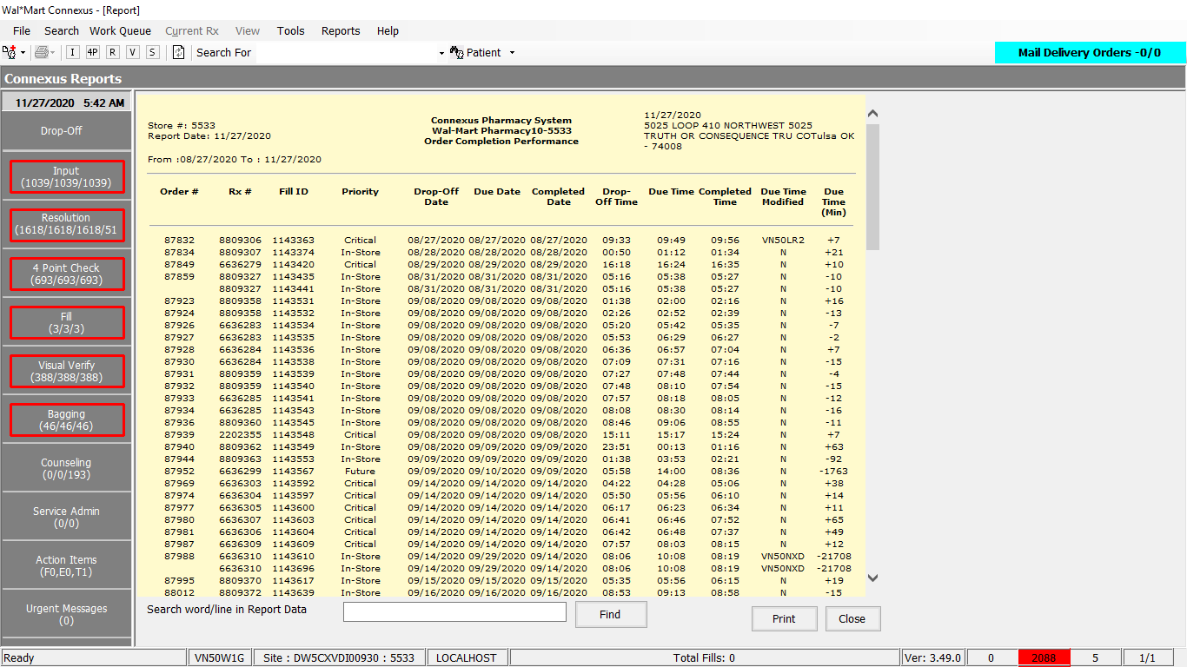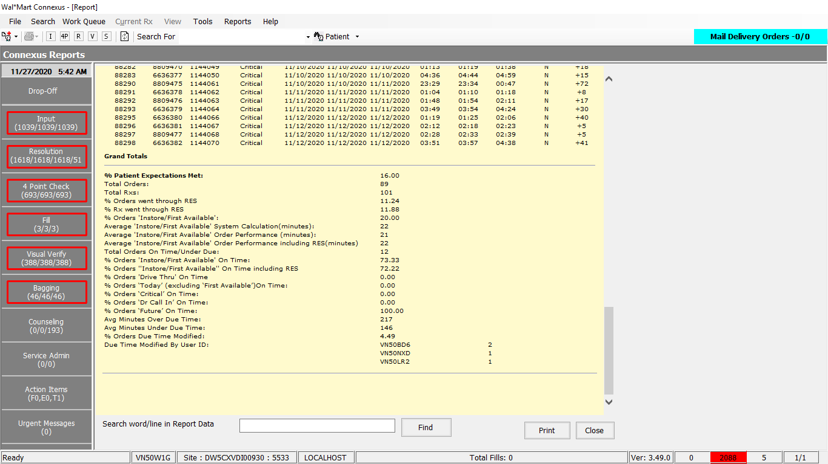

Query:

1. Friend Const OrderCompletionPerformanceDetails As String = "SELECT DISTINCT od.order_id" +

" ,rx.rx_nbr" +

" ,od.rx_fill_id" +

" ,pt.priority_desc" +

" ,DATE(co.order_entry_ts) DropOffDate" +

" ,DATE(DECODE(od.promise_ready_ts,NULL,od.est_pickup_ts,od.promise_ready_ts)) DueDate" +

" ,DATE(rxa.activity_ts) CompletedDate" +

" ,TO_CHAR(co.order_entry_ts, ""%H:%M"") DropOffTime" +

" ,TO_CHAR(DECODE(od.promise_ready_ts,NULL,od.est_pickup_ts,od.promise_ready_ts), ""%H:%M"") DueTime" +

" ,TO_CHAR(rxa.activity_ts, ""%H:%M"") CompletedTime" +

" ,coa.activity_userid" +

" ,NVL((rxa.activity_ts - DECODE(od.promise_ready_ts,NULL,od.est_pickup_ts,od.promise_ready_ts))::interval minute(9) to minute :: char(10)::int, 0) underdue " +

" ,rx.patient_id" +

" FROM customer_order co, rx_order_detail od, rx, rx_fill_activity rxa, " +

" OUTER cust_ord_activity coa, OUTER rx_priority_txt pt " +

" WHERE co.order_id = od.order_id " +

" AND od.rx_id = rx.rx_id" +

" AND od.rx_fill_id = rxa.rx_fill_id" +

" AND rxa.activity_code = 8631" +

" AND coa.order_id = od.order_id" +

" AND (coa.activity_code = 8625 OR coa.activity_code = 8651)" +

" AND pt.priority_id = co.priority_id" +

" AND rxa.activity_ts=( " +

" SELECT MIN(irxa.activity_ts) as activity_ts " +

" FROM rx_fill_activity irxa " +

" WHERE rxa.rx_fill_id = irxa.rx_fill_id " +

" AND irxa.activity_code=8631 " +

" AND od.est_pickup_ts > co.order_entry_ts" +

" AND DATE(irxa.activity_ts) BETWEEN DATE(?) AND DATE(?) " +

" GROUP BY irxa.rx_fill_id " +

" ) " +

" AND DATE(co.order_entry_ts) BETWEEN DATE(?) AND DATE(?) "

2. Friend Const OrderCompletionPerformancePriorityAnd As String = " AND (co.priority_id = ?"

3. Friend Const OrderCompletionPerformancePriorityOr As String = " OR co.priority_id = ?"

4. Friend Const OrderCompletionPerformanceOrderBy As String = " Order By "

5. Friend Const OrderCompletionDueTimeChanged As String =

"SELECT coa.activity_userid, COUNT(UNIQUE cuo.order_id) order_count" +

" FROM customer_order cuo, cust_ord_activity coa, " +

" rx_order_detail rod, rx_fill_activity rxa " +

" WHERE cuo.order_id = coa.order_id" +

" AND cuo.order_id = rod.order_id" +

" AND coa.activity_code=8651" +

" AND rod.rx_fill_id = rxa.rx_fill_id " +

" AND rxa.activity_code = 8631" +

" AND rxa.activity_ts=( " +

" SELECT MIN(irxa.activity_ts) as activity_ts " +

" FROM rx_fill_activity irxa " +

" WHERE rxa.rx_fill_id = irxa.rx_fill_id " +

" AND irxa.activity_code=8631 " +

" AND DATE(irxa.activity_ts) BETWEEN DATE(?) AND DATE(?) " +

" GROUP BY irxa.rx_fill_id " +

" ) " +

" AND DATE(cuo.order_entry_ts) BETWEEN DATE(?) AND DATE(?) " +

" GROUP BY coa.activity_userid"

6. Friend Const OrderCompletionPerformanceOrderCount As String = "SELECT COUNT(distinct od.order_id) OrderCount "

-------------

7. Friend Const OrderCompletionBody As String = "FROM customer_order co, rx_order_detail od, rx_fill_activity rxa " +

"WHERE od.rx_fill_id = rxa.rx_fill_id" +

" AND co.order_id = od.order_id" +

" AND rxa.activity_code = 8631" +

" AND rxa.activity_ts=( " +

" SELECT MIN(irxa.activity_ts) as activity_ts " +

" FROM rx_fill_activity irxa " +

" WHERE rxa.rx_fill_id = irxa.rx_fill_id " +

" AND irxa.activity_code=8631 " +

" AND DATE(irxa.activity_ts) BETWEEN DATE(?) AND DATE(?) " +

" GROUP BY irxa.rx_fill_id " +

" ) " +

" AND DATE(co.order_entry_ts) BETWEEN DATE(?) AND DATE(?) "

8. Friend Const OrderCompletionRxCount As String = "SELECT COUNT(rx_id) NoOfRX "

9. Friend Const OrderCompletionInTrouble As String = " AND co.order_id IN( " +

"SELECT DISTINCT order_id " +

" FROM rx_ord_dtl_activty " +

" WHERE work_que_code = 7 " +

" AND (activity_code = 1100 OR activity_code = 1122))"

10. Friend Const OrderCompletionAvgDueTime As String = "SELECT NVL(AVG(rxa.activity_ts - DECODE(od.promise_ready_ts,NULL,od.est_pickup_ts,od.promise_ready_ts))::interval minute(9) to minute :: char(10), '0') AvgDueTime "

-------------------------------------------------------------

11. Friend Const OrderCompletionOverDueCondition As String = " AND DECODE(od.promise_ready_ts,NULL,od.est_pickup_ts,od.promise_ready_ts) < rxa.activity_ts" +

" AND od.est_pickup_ts > co.order_entry_ts" +

" AND (rxa.activity_ts - DECODE(od.promise_ready_ts,NULL,od.est_pickup_ts,od.promise_ready_ts) )::INTERVAL MINUTE(9) TO MINUTE :: CHAR(10) :: INT > 0 "

12. Friend Const OrderCompletionUnderDueTime As String = "SELECT NVL(AVG(DECODE(od.promise_ready_ts,NULL,od.est_pickup_ts,od.promise_ready_ts) - rxa.activity_ts)::interval minute(9) to minute :: char(10), '0') AvgUnderTime "

-------------------------------------------------------------------------

13. Friend Const orderCompletionUnderDueAverage As String = " AND (DECODE(od.promise_ready_ts,NULL,od.est_pickup_ts,od.promise_ready_ts) > rxa.activity_ts AND (DECODE(od.promise_ready_ts,NULL,od.est_pickup_ts,od.promise_ready_ts) " +

" - rxa.activity_ts)::interval minute(9) to minute :: char(10):: int > 0 )"

14. Friend Const OrderCompletionPriorityFilter As String = " AND co.order_id NOT IN(SELECT order_id FROM cust_ord_activity WHERE activity_code = 8625) "

15. Friend Const OrderCompletionNotInTSFilter As String = " AND co.order_id NOT IN( SELECT DISTINCT order_id FROM rx_ord_dtl_activty WHERE work_que_code = 7 AND (activity_code = 1100 OR activity_code = 1122))"

16. Friend Const OrderCompletionOrderPerfomance As String = "SELECT NVL(AVG(rxa.activity_ts -co.order_entry_ts)::interval minute(9) to minute :: char(10), '0') OrderPerfomance "

16. Friend Const OrderCompletionPerformanceOrderCount As String = "SELECT COUNT(distinct od.order_id) OrderCount "

17. Friend Const OrderCompletionUnderDueCondition As String = " AND (DECODE(od.promise_ready_ts,NULL,od.est_pickup_ts,od.promise_ready_ts) > rxa.activity_ts OR (DECODE(od.promise_ready_ts,NULL,od.est_pickup_ts,od.promise_ready_ts) " +

" - rxa.activity_ts)::interval minute(9) to minute :: char(10):: int = 0 )" +

" AND od.order_id NOT IN (SELECT order_id FROM rx_order_detail rod WHERE (DECODE(promise_ready_ts,NULL,est_pickup_ts,promise_ready_ts)) < " +

" (SELECT MIN(rfa.activity_ts) as activity_ts FROM rx_fill_activity rfa WHERE rfa.rx_fill_id = rod.rx_fill_id AND rfa.activity_code=8631 GROUP BY rfa.rx_fill_id ))"

Dal:

Public Function GetOrderCompletionPerformanceReport(ByVal reportParams As _

OrderCompletionPerformanceReportParamsBE) As _

OrderCompletionPerformanceReportBE Implements IReportDAL.GetOrderCompletionPerformanceReport

Using (New Tracer(ConnexusCommonConstants.ConnexusTracer))

Dim orderCompletionPerformanceReport As New OrderCompletionPerformanceReportBE

Dim strQuery As String = String.Empty

Dim paramList As New List(Of DbParameter)

Dim dataReader As IDataReader

Dim paramListWithoutCompleted As New List(Of DbParameter)

Dim lstOrderCompletionPerformanceDetail As New List(Of OrderCompletionPerformanceReportDetailBE)

'Get Order Completion Performance Details

If reportParams.IsSummary = 2 Then

paramList.Add(ParameterHelper.BuildParameter("DropOffStartDate", DbType.Date, reportParams.DropOffStartDate))

paramList.Add(ParameterHelper.BuildParameter("CompletedStartDate", DbType.Date, reportParams.CompletedStartDate))

paramList.Add(ParameterHelper.BuildParameter("DropOffStartDate", DbType.Date, reportParams.DropOffStartDate))

paramList.Add(ParameterHelper.BuildParameter("CompletedStartDate", DbType.Date, reportParams.CompletedStartDate))

Dim priorityCheck As String = String.Empty

strQuery = ReportQueries.OrderCompletionPerformanceDetails

For Each priority As Integer In reportParams.Priority

If priorityCheck = String.Empty Then

priorityCheck = ReportQueries.OrderCompletionPerformancePriorityAnd

paramList.Add(ParameterHelper.BuildParameter("Priority" + priority.ToString.Trim,

DbType.Int32, priority))

Continue For

End If

priorityCheck = priorityCheck + ReportQueries.OrderCompletionPerformancePriorityOr

paramList.Add(ParameterHelper.BuildParameter("Priority" + priority.ToString.Trim,

DbType.Int32, priority))

Next

If Not priorityCheck = String.Empty Then

priorityCheck = priorityCheck + ")"

End If

strQuery = strQuery + priorityCheck +

ReportQueries.OrderCompletionPerformanceOrderBy + reportParams.SortBy.ToString + ",1 ;"

dataReader = ExecuteReader(DatabaseEnum.rx21c,

reportParams.SiteId,

strQuery,

paramList)

While dataReader.Read

Dim orderCompletionPerformanceDetail As New OrderCompletionPerformanceReportDetailBE

If Not dataReader.IsDBNull(dataReader.GetOrdinal("patient_id")) Then

orderCompletionPerformanceDetail.PatientID = CInt(dataReader("patient_id")).ToString

End If

If Not dataReader.IsDBNull(dataReader.GetOrdinal("order_id")) Then

orderCompletionPerformanceDetail.OrderNumber = CInt(dataReader("order_id")).ToString

End If

If Not dataReader.IsDBNull(dataReader.GetOrdinal("rx_nbr")) Then

orderCompletionPerformanceDetail.RxNumber = CInt(dataReader("rx_nbr")).ToString

End If

If Not dataReader.IsDBNull(dataReader.GetOrdinal("rx_fill_id")) Then

orderCompletionPerformanceDetail.FillID = CInt(dataReader("rx_fill_id")).ToString

End If

If Not dataReader.IsDBNull(dataReader.GetOrdinal("priority_desc")) Then

orderCompletionPerformanceDetail.Priority = dataReader("priority_desc").ToString

End If

If Not dataReader.IsDBNull(dataReader.GetOrdinal("DropOffDate")) Then

orderCompletionPerformanceDetail.DropOffDate = CDate(dataReader("DropOffDate")).ToString

End If

If Not dataReader.IsDBNull(dataReader.GetOrdinal("DueDate")) Then

orderCompletionPerformanceDetail.DueDate = CDate(dataReader("DueDate")).ToString

End If

If Not dataReader.IsDBNull(dataReader.GetOrdinal("CompletedDate")) Then

orderCompletionPerformanceDetail.CompletedDate = CDate(dataReader("CompletedDate")).ToString

End If

orderCompletionPerformanceDetail.DropOffTime = dataReader("DropOffTime").ToString

orderCompletionPerformanceDetail.DropOffTime = dataReader("DropOffTime").ToString

orderCompletionPerformanceDetail.DueTime = dataReader("DueTime").ToString

orderCompletionPerformanceDetail.CompletedTime = dataReader("CompletedTime").ToString

If Not dataReader.IsDBNull(dataReader.GetOrdinal("activity_userid")) Then

orderCompletionPerformanceDetail.DueDateChanged = dataReader("activity_userid").ToString

End If

orderCompletionPerformanceDetail.RxDueTime = dataReader("underdue").ToString

lstOrderCompletionPerformanceDetail.Add(orderCompletionPerformanceDetail)

End While

End If

paramList = New List(Of DbParameter)

paramList.Add(ParameterHelper.BuildParameter("DropOffStartDate", DbType.Date, reportParams.DropOffStartDate))

paramList.Add(ParameterHelper.BuildParameter("CompletedStartDate", DbType.Date, reportParams.CompletedStartDate))

paramList.Add(ParameterHelper.BuildParameter("DropOffStartDate", DbType.Date, reportParams.DropOffStartDate))

paramList.Add(ParameterHelper.BuildParameter("CompletedStartDate", DbType.Date, reportParams.CompletedStartDate))

'Get details of due time changed

Dim lstOrderCompletionPerformancePriority As New List(Of OrderCompletionPerformanceReportPriorityBE)

strQuery = ReportQueries.OrderCompletionDueTimeChanged + ";"

dataReader = ExecuteReader(DatabaseEnum.rx21c,

reportParams.SiteId,

strQuery,

paramList)

While dataReader.Read

Dim orderCompletionPerformancePriority As New OrderCompletionPerformanceReportPriorityBE

If Not dataReader.IsDBNull(dataReader.GetOrdinal("activity_userid")) Then

orderCompletionPerformancePriority.UserID = dataReader("activity_userid").ToString

End If

If Not dataReader.IsDBNull(dataReader.GetOrdinal("order_count")) Then

orderCompletionPerformancePriority.DueChangeCount = CInt(dataReader("order_count")).ToString

End If

lstOrderCompletionPerformancePriority.Add(orderCompletionPerformancePriority)

End While

'Get order Completion Performance Summary

paramListWithoutCompleted.Add(ParameterHelper.BuildParameter("DropOffStartDate", DbType.Date, reportParams.DropOffStartDate))

paramListWithoutCompleted.Add(ParameterHelper.BuildParameter("CompletedStartDate", DbType.Date, reportParams.CompletedStartDate))

paramListWithoutCompleted.Add(ParameterHelper.BuildParameter("DropOffStartDate", DbType.Date, reportParams.DropOffStartDate))

paramListWithoutCompleted.Add(ParameterHelper.BuildParameter("CompletedStartDate", DbType.Date, reportParams.CompletedStartDate))

'Total orders

strQuery = ReportQueries.OrderCompletionPerformanceOrderCount +

ReportQueries.OrderCompletionBody + ";"

dataReader = ExecuteReader(DatabaseEnum.rx21c,

reportParams.SiteId,

strQuery,

paramListWithoutCompleted)

Dim orderCompletionPerformanceSummary As New OrderCompletionPerformanceReportSummaryBE

While dataReader.Read

If Not dataReader.IsDBNull(dataReader.GetOrdinal("OrderCount")) Then

orderCompletionPerformanceSummary.TotalOrders = CInt(dataReader("OrderCount")).ToString

End If

End While

'Total Rx

strQuery = ReportQueries.OrderCompletionRxCount +

ReportQueries.OrderCompletionBody + ";"

dataReader = ExecuteReader(DatabaseEnum.rx21c,

reportParams.SiteId,

strQuery,

paramListWithoutCompleted)

While dataReader.Read

If Not dataReader.IsDBNull(dataReader.GetOrdinal("NoOfRX")) Then

orderCompletionPerformanceSummary.TotalRx = CInt(dataReader("NoOfRX")).ToString

End If

End While

'Order went in TS

strQuery = ReportQueries.OrderCompletionPerformanceOrderCount +

ReportQueries.OrderCompletionBody +

ReportQueries.OrderCompletionInTrouble + ";"

dataReader = ExecuteReader(DatabaseEnum.rx21c,

reportParams.SiteId,

strQuery,

paramList)

While dataReader.Read

If Not dataReader.IsDBNull(dataReader.GetOrdinal("OrderCount")) Then

orderCompletionPerformanceSummary.OrderWentInTS = CInt(dataReader("OrderCount")).ToString

End If

End While

'Rx went in TS

strQuery = ReportQueries.OrderCompletionRxCount +

ReportQueries.OrderCompletionBody +

ReportQueries.OrderCompletionInTrouble + ";"

dataReader = ExecuteReader(DatabaseEnum.rx21c,

reportParams.SiteId,

strQuery,

paramListWithoutCompleted)

While dataReader.Read

If Not dataReader.IsDBNull(dataReader.GetOrdinal("NoOfRX")) Then

orderCompletionPerformanceSummary.RxWentInTS = CInt(dataReader("NoOfRX")).ToString

End If

End While

'Average Minutes Over Due

strQuery = ReportQueries.OrderCompletionAvgDueTime +

ReportQueries.OrderCompletionBody + ReportQueries.OrderCompletionOverDueCondition + ";"

dataReader = ExecuteReader(DatabaseEnum.rx21c,

reportParams.SiteId,

strQuery,

paramList)

While dataReader.Read

orderCompletionPerformanceSummary.AverageOverDue = dataReader("AvgDueTime").ToString

End While

'Average Minutes Under Due

strQuery = ReportQueries.OrderCompletionUnderDueTime +

ReportQueries.OrderCompletionBody +

ReportQueries.orderCompletionUnderDueAverage +

ReportQueries.OrderCompletionPriorityFilter +

ReportQueries.OrderCompletionNotInTSFilter + ";"

dataReader = ExecuteReader(DatabaseEnum.rx21c,

reportParams.SiteId,

strQuery,

paramList)

While dataReader.Read

If Not dataReader.IsDBNull(dataReader.GetOrdinal("AvgUnderTime")) Then

orderCompletionPerformanceSummary.AverageUnderDue = dataReader("AvgUnderTime").ToString

End If

End While

'No of orders for due time changed

strQuery = ReportQueries.OrderCompletionOrdersDueTimeChanged + ";"

dataReader = ExecuteReader(DatabaseEnum.rx21c,

reportParams.SiteId,

strQuery,

sss

While dataReader.Read

If Not dataReader.IsDBNull(dataReader.GetOrdinal("Order_Count")) Then

orderCompletionPerformanceSummary.NoOfDueTimeModified = CInt(dataReader("Order_Count")).ToString

End If

End While

'First Available Average System

paramListWithoutCompleted.Add(ParameterHelper.BuildParameter("Priority", DbType.Int32,

OrderPriority.wmPriorityFirstAvailable))

strQuery = ReportQueries.OrderCompletionSystemCalc +

ReportQueries.OrderCompletionBody +

ReportQueries.OrderCompletionPerformancePriority +

ReportQueries.OrderCompletionPriorityFilter +

ReportQueries.OrderCompletionNotInTSFilter + ";"

dataReader = ExecuteReader(DatabaseEnum.rx21c,

reportParams.SiteId,

strQuery,

paramListWithoutCompleted)

While dataReader.Read

If Not dataReader.IsDBNull(dataReader.GetOrdinal("AvgSystemCalc")) Then

orderCompletionPerformanceSummary.AverageFirstAvailableSystem =

dataReader("AvgSystemCalc").ToString

End If

End While

'First avaialbe average peroformance

paramList.Add(ParameterHelper.BuildParameter("Priority", DbType.Int32,

OrderPriority.wmPriorityFirstAvailable))

strQuery = ReportQueries.OrderCompletionOrderPerfomance +

ReportQueries.OrderCompletionBody +

ReportQueries.OrderCompletionPerformancePriority +

ReportQueries.OrderCompletionPriorityFilter +

ReportQueries.OrderCompletionNotInTSFilter + ";"

dataReader = ExecuteReader(DatabaseEnum.rx21c,

reportParams.SiteId,

strQuery,

paramList)

While dataReader.Read

If Not dataReader.IsDBNull(dataReader.GetOrdinal("OrderPerfomance")) Then

orderCompletionPerformanceSummary.AverageFirstAvailablePerformance =

dataReader("OrderPerfomance").ToString

End If

End While

'First avaialbe average peroformance incl

paramList.Add(ParameterHelper.BuildParameter("Priority", DbType.Int32,

OrderPriority.wmPriorityFirstAvailable))

strQuery = ReportQueries.OrderCompletionOrderPerfomance +

ReportQueries.OrderCompletionBody +

ReportQueries.OrderCompletionPerformancePriority +

ReportQueries.OrderCompletionPriorityFilter + ";"

dataReader = ExecuteReader(DatabaseEnum.rx21c,

reportParams.SiteId,

strQuery,

paramList)

While dataReader.Read

If Not dataReader.IsDBNull(dataReader.GetOrdinal("OrderPerfomance")) Then

orderCompletionPerformanceSummary.AverageFirstAvailablePerformanceInTS =

dataReader("OrderPerfomance").ToString

End If

End While

'First available on time including TS

strQuery = ReportQueries.OrderCompletionPerformanceOrderCount +

ReportQueries.OrderCompletionBody +

ReportQueries.OrderCompletionPerformancePriority +

ReportQueries.OrderCompletionUnderDueCondition +

ReportQueries.OrderCompletionPriorityFilter

dataReader = ExecuteReader(DatabaseEnum.rx21c,

reportParams.SiteId,

strQuery,

paramList)

While dataReader.Read

If Not dataReader.IsDBNull(dataReader.GetOrdinal("OrderCount")) Then

orderCompletionPerformanceSummary.FirstAvailablePercentageOnTimeTS = Convert.ToDouble(dataReader("OrderCount")).ToString

End If

End While

'Total First Available including TS

strQuery = ReportQueries.OrderCompletionPerformanceOrderCount +

ReportQueries.OrderCompletionBody +

ReportQueries.OrderCompletionPerformancePriority +

ReportQueries.OrderCompletionPriorityFilter

dataReader = ExecuteReader(DatabaseEnum.rx21c,

reportParams.SiteId,

strQuery,

paramList)

While dataReader.Read

If Not dataReader.IsDBNull(dataReader.GetOrdinal("OrderCount")) Then

orderCompletionPerformanceSummary.OrderFirstAvailableOnTimeTS = Convert.ToDouble(dataReader("OrderCount")).ToString

End If

End While

'Total orders completed on time

orderCompletionPerformanceSummary.OrdersOnTime =

GetPriorityCountForOrderCompletion(OrderPriority.wmWithoutPriority, reportParams).ToString

'First Available not in TS and priority not changed

orderCompletionPerformanceSummary.FirstAvailablePercentage =

GetPriorityCountForOrders(OrderPriority.wmPriorityFirstAvailable, reportParams).ToString

'Total orders not in TS and priority not changed

orderCompletionPerformanceSummary.OrdersCompleted =

GetPriorityCountForOrders(OrderPriority.wmWithoutPriority, reportParams).ToString()

'Patient met expectation

orderCompletionPerformanceSummary.MeetsExpectationPercentage =

GetPriorityPercentageForOrderCompletion(OrderPriority.wmWithoutPriority, reportParams)

'First available

orderCompletionPerformanceSummary.FirstAvailablePercentageOnTime =

GetPriorityPercentageForOrderCompletion(OrderPriority.wmPriorityFirstAvailable, reportParams)

'Critical

orderCompletionPerformanceSummary.CriticalPercentage =

GetPriorityPercentageForOrderCompletion(OrderPriority.wmPriorityCritical, reportParams)

'Future

orderCompletionPerformanceSummary.FuturePercentage =

GetPriorityPercentageForOrderCompletion(OrderPriority.wmPriorityFuture, reportParams)

'Dr Call In

orderCompletionPerformanceSummary.DrCallPercentage =

GetPriorityPercentageForOrderCompletion(OrderPriority.wmPriorityDrCallIn, reportParams)

'Today

orderCompletionPerformanceSummary.DriveThroughPercentage =

GetPriorityPercentageForOrderCompletion(OrderPriority.wmPriorityDriveThru, reportParams)

'Today

orderCompletionPerformanceSummary.TodayPercentage =

GetPriorityPercentageForOrderCompletion(OrderPriority.wmPriorityToday, reportParams)

orderCompletionPerformanceReport.OrderCompletionPerformanceReportDetail =

lstOrderCompletionPerformanceDetail

orderCompletionPerformanceReport.OrderCompletionPerformanceReportSummary =

orderCompletionPerformanceSummary

orderCompletionPerformanceReport.OrderCompletionPerformanceReportPriority =

lstOrderCompletionPerformancePriority

Return orderCompletionPerformanceReport

End Using

End Function